Python Notes

Python and Anaconda are two different distribution of Python
The of package manager of Anaconda known as conda.
----------------------------------------
On Windows command prompt writing python will start the Python interpreter
Python interpreter prompt is >>>
one can directly write python commands on this prompt, e.g.,
print("Hello world!")

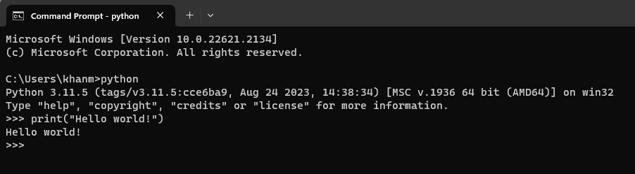
to exit from the Python Python interpreter
>>>exit()

check python version
>python --version

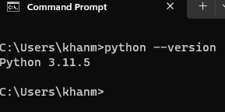

Task | Command
 | python --version
upgrade pip | py -m pip install --upgrade pip
install numpy package | >py -m pip install numpy
install panda package | >py -m pip install pandas
install matplotlib package | >py -m pip install matplotlib
upgrade numpy | > pip install --upgrade numpy
Install csv | > pip install csv
Nltk (natural language toolkit) | > pip install nltk
 | > pip install pandas
 | > pip install genism
 | > pip install pyLDAvis
 | > pip install spacy
 | >pip install seaborn
 | >pip install xgboost

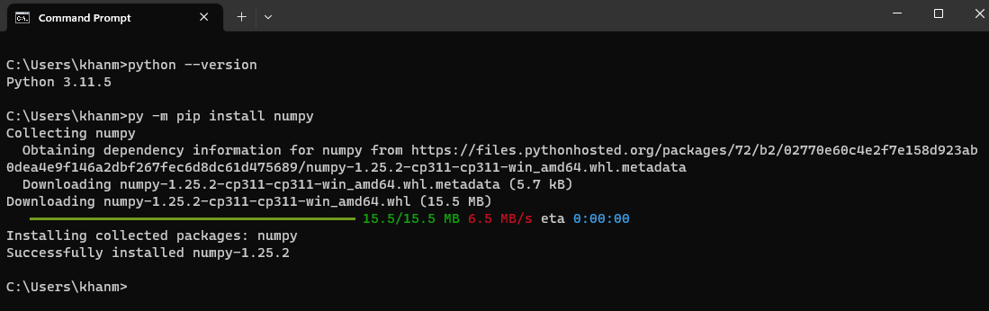

NLTK download and Install
NLTK's stopwords requires the stopwords to be first downloaded via the NLTK Data installer. This is a one-time setup, after which you will be able to freely use from nltk.corpus import stopwords.
To download the stopwords, open the Python interpreter with python in your terminal of choice, and type:
>>> import nltk
>>> nltk.download("stopwords")
>>> nltk.download('punkt')

Then in the python script use following
from nltk.corpus import stopwords

